LATITUDE AND LONGITUDE
Latitude lines are imaginary lines on the earth's surface. They run east and west around the globe and tell you your distance north or south of the Equator.
Think of latitude like the rungs of a ladder (ladder sounds a lot like latitude). Latitude lines run east and west, but they tell how far up (north) you can go or how far down (south) you can go.
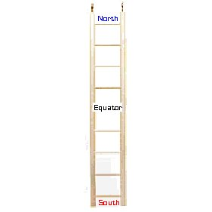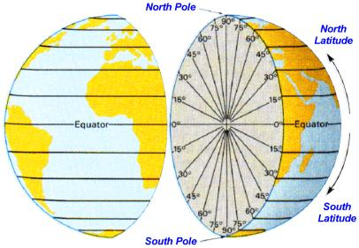
Longitude lines are imaginary lines on the earth's surface that run from pole to pole around the globe and tell you your distance east or west from the Prime Meridian.
When you think of longitude, think of long, tall telephone poles (because longitude lines run from pole to pole). Longitude lines run north and south, but they tell how far east you can go or how far west you can go.
